Moggill Pony Club Maintenance Job

Stable Side - Corner area near Caretaker caravan
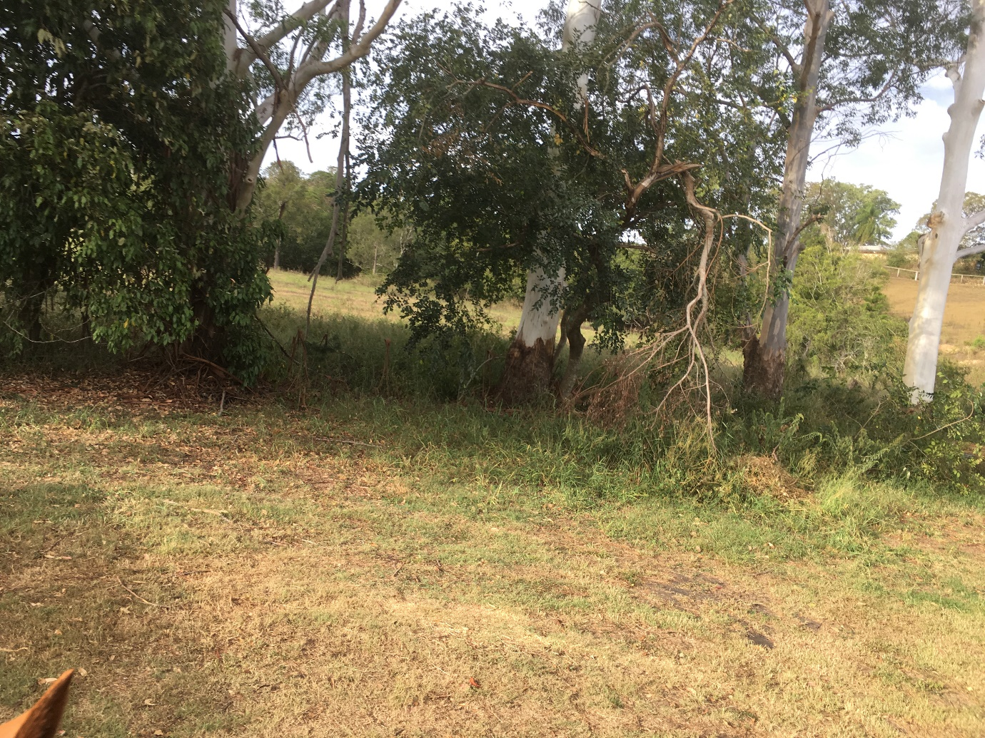

Whipper snip area and fence line, stack up fallen branches – create neat pile in area for pick up later
PPE: Ear muff/ Plugs
Long pants/ leg guards
Face shield / safety glasses
Gloves
Time: 1 ½ hours

