Moggill Pony Club Maintenance Job

Stable Side - Front Fence top Corner
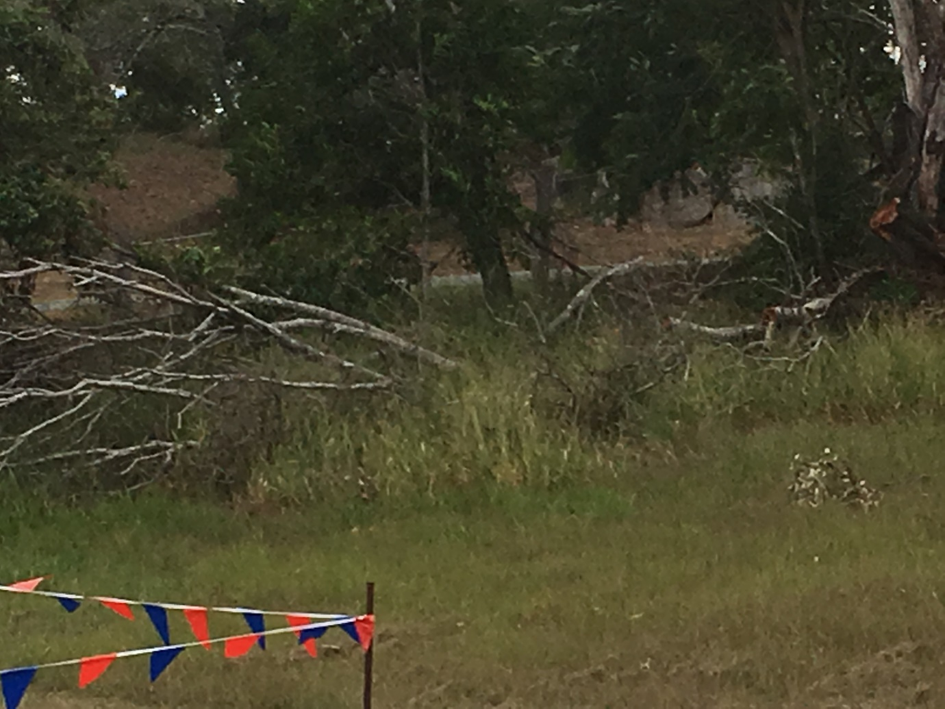

Cut up tree, and Whipper snip around fallen tree & fence line from bottom of bottom of hill to corner. Stack timber and branches in area in a neat pile for pick up later.
PPE: Ear muff/ Plugs
Long pants/ leg guards
Face shield / safety glasses
Gloves
Time: 1 ½ hours

