Moggill Pony Club Maintenance Job

Top Corner - End of Stables
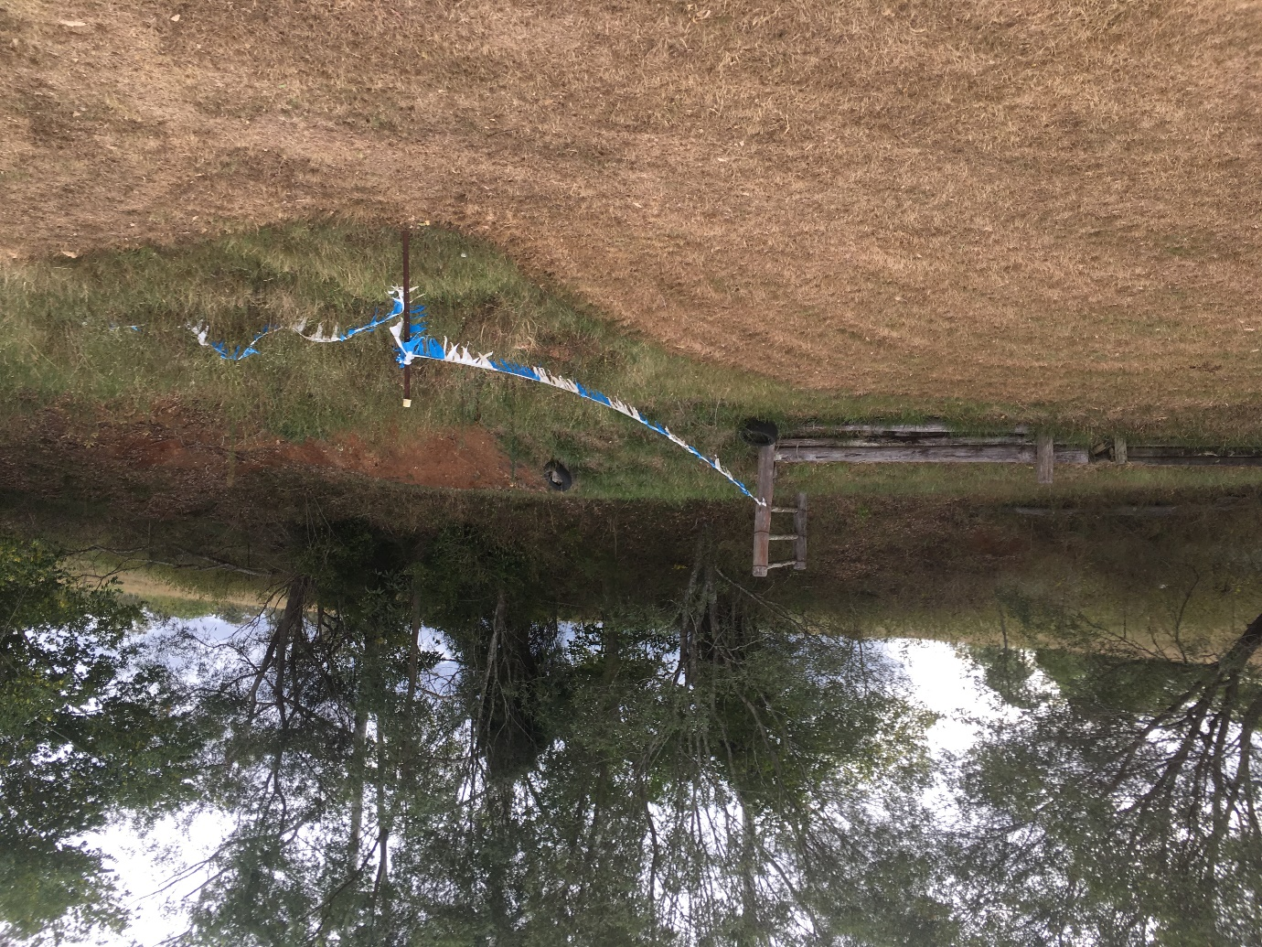

Whipper snip area at end of stables (top boundary corner) and clean up tree branches in area
PPE: Ear muff/ Plugs
Long pants/ leg guards
Face shield / safety glasses
Gloves
Time: 1 hour

