MPC Committee Meeting Minutes
MOGGILL PONY CLUB
Location: 216 Sugars Rd, Anstead
Date: 19th September, 2019
Time: 1900
- Meeting Opened
  - Welcome and apologies
Present: Gemma Burger, Di Toll, Belinda Ryder, Shane Toll, Keirra Middleton, Tanya Holliman, Dan Foster, Carmen Coombs
Apologies: Kelly Foster, Dale Innes
1.2 Disclosure of conflicts of interest - nil
1.3 Minutes of the previous meeting – motion that the minutes were a true and accurate record
Moved: Shane Toll Seconded: Belinda Ryder
- REPORTS AND MATTERS FOR DECISION
PRESIDENTS REPORT
Agenda
- Presidents Items
- Treasurer
  - Transfer
    - Additional account with Heritage? – not yet active, was just a floated idea. NAB proving difficult to work with

- Sponsorship
  - Sponsorship Information
  - Actions from last month’s meeting confirming deposits into Accounts? – all sponsors have been invoiced

- Hack Day thank you to all for a great event, the feedback from all that I spoke to was all positive, special mention for the judges for the day “being very informative and helpful to all”

- Equipment
  - Equipment Wish List
    - Christian Rowan has delivered us a new Stainless Steel BBQ. Official thanks to be organized by Gemma
.

- Constitution
    - I need to catch up with James in the coming week to get a handover of the issue.
- Lighting
    - Cable has been laid from the club house to the stables, work should be completed in the coming weeks . Stable area to be out of action Monday and Tuesday 23-24/9/19. Excavation work is more expensive than originally thought - still have remaining grant money available. PA speakers are not working – electrician has recommended full WIFI system for PA - approximately $1000 for system (await quote) Would not cover to round yard.
- Robbie’s House
  - Di is working though this and should have more details.

- Number of committee member required for each muster, this is the only place most members can interact with the committee, I know we all have other commitments, but we need to work out a way to ensure that we have representation for the rest of the musters. Possibly committee is too small; engage more committee members

- Ways to better engage the new members we have at the club. Buddying up newer members with older members to help with competition/questions; touch base before their first rally (Keirra); engage people at rallies with certain tasks

- Set the dates for the rest of the events we have planned for the year, possible night competition?

Motion: The President’s Report be accepted into the minutes.
Moved: Shane Toll Seconded: Belinda Ryder

MEMBERSHIP SECRETARY REPORT
5 new members – associate riders x3, 1 riding, 1 adult riding member
Another new enquiry
Pro rata membership currently
Received James’ letter of resignation
If anyone enquiring about membership whom currently has membership of another pony club, need to confirm no outstanding charges for that member. (previous club has to release the member)
If moving from another club, 6 week wait before competing
All new members must have attended 2 rallies before competing
Motion: The Secretary’s Report be accepted into the minutes.
Moved: Keirra Middleton Seconded: Shane Toll

TREASURERS REPORT
- Page 3 –Positive account balance growth over same period. September Hack Day will further improve cash position. General expenditure has increased YOY.
- Page 4 –Account balances note favourable position YOY. Consideration must be given to appropriate Levy contingent liability value at end of year due to number of members.
- Page 5 –All revenue departments making sound contributions at gross and net levels. Grants, Memberships, Nominations and Events are intrinsic to the continued growth, investment and success of MPC and are its cornerstone. Net performance of Canteen & Merchandise is based only on YTD expensed items and would improve if prepaid and expensed inventory was captured (via Balance Sheet -complete inventory detail not readily available). This will be reflected in 2019 financial statements.
- Page 6. Expenditure is in line with expectations and whilst it has increased YOY, this is largely attributed to revenue generating investment and activity, all of which are making a sound return on the associated investment.
- Page 7. Signage costs have considerably diluted YTD net income for this excellent initiative; as payments received the position will improve considerably. Underlined sponsors are in arrears. Consideration to be given as to who owns collections activity of payments now due/overdue. Shane to chase up re overdue payments; Moggill Barn; TMRP; Brisbane Real Estate.
- General housekeeping
- All financial entries for 2019 are now reconciled –refer pages 8 & 9 for full YTD breakdown.
- All payments and invoices are up to date as of 12 September 2019.
- Reimbursement claims of expenses should be made in a timely manner so as to maintain an accurate position for budgeting. Recommendation is <14 days. All receipts (or scans thereof) should be presented at the time of the reimbursement claim.
- For continuity and completeness, Canteen and Merchandise revenues and expenses are aggregated. It is recommended for FY20 that these are separated.

Date | Description |  | Category | CR/DB |  | Balance
31-Dec-18 |  | Opening Balance -carried forward? |  |  | $ 12,568.50
03-Jan-19 | INTERNET BPAY BCC RATES 500000002641031 |  | Operations | -$ 1,130.95 |  | $ 11,437.55
03-Jan-19 | 24Dec18 To 30Dec18 OMNISPORTSMNGMT Moggill Pony Clu |  | Membership Dues | $ 390.00 |  | $ 11,827.55
03-Jan-19 | 17Dec18 To 23Dec18 OMNISPORTSMNGMT Moggill Pony Clu |  | Membership Dues | $ 780.00 |  | $ 12,607.55
08-Jan-19 | RYDER PD*BG Ryder Dec Camp . |  | Event Fees | $ 136.90 |  | $ 12,744.45
08-Jan-19 | 31Dec18 To 06Jan19 OMNISPORTSMNGMT Moggill Pony Clu |  | Membership Dues | $ 1,190.00 |  | $ 13,934.45
15-Jan-19 | INTERNET TRANSFER Levy Refund |  | Membership/Levy Refunds | -$ 280.00 |  | $ 13,654.45
16-Jan-19 | 07Jan19 To 13Jan19 OMNISPORTSMNGMT Moggill Pony Clu |  | Membership Dues | $ 1,060.00 |  | $ 14,714.45
21-Jan-19 | INTERNET TRANSFER Inv 327 |  | R&M and non-capitalised equipment | -$ 2,910.00 |  | $ 11,804.45
22-Jan-19 | CANTEEN SJ |  | Canteen/Product Sales | $ 30.00 |  | $ 11,834.45
22-Jan-19 | BCC2000075631 BRISBANE CITY CO MOGGILL PONY CLU |  | Grant Income | $ 3,400.00 |  | $ 15,234.45
23-Jan-19 | 14Jan19 To 20Jan19 OMNISPORTSMNGMT Moggill Pony Clu |  | Membership Dues | $ 930.00 |  | $ 16,164.45
25-Jan-19 | INTERNET TRANSFER Inv 0045 |  | R&M and non-capitalised equipment | -$ 304.00 |  | $ 15,860.45
29-Jan-19 | Clare Robinson SCENIC RIM DEVEL Moggill Pony Clu |  | Canteen/Product Sales | $ 20.00 |  | $ 15,880.45
29-Jan-19 | SQUARE AU PTY LT Moggill Pony Clu |  | Canteen/Product Sales | $ 202.02 |  | $ 16,082.47
30-Jan-19 | Leisha Bennett LEISHA BENNETT Moggill Pony Clu |  | Canteen/Product Sales | $ 12.00 |  | $ 16,094.47
30-Jan-19 | 21Jan19 To 27Jan19 OMNISPORTSMNGMT Moggill Pony Clu |  | Membership Dues | $ 2,070.00 |  | $ 18,164.47
30-Jan-19 | STCO71700 DEPT OF INFRA MOGGILL PC |  | Grant Income | $ 20,000.00 |  | $ 38,164.47
06-Feb-19 | 28Jan19 To 03Feb19 OMNISPORTSMNGMT Moggill Pony Clu |  | Membership Dues | $ 850.00 |  | $ 39,014.47
08-Feb-19 | INTERNET TRANSFER Stable Payment Moggil Pony Club |  | Renovations | -$ 4,475.00 |  | $ 34,539.47
08-Feb-19 | DEC CAMP |  | Canteen/Product Sales | $ 56.00 |  | $ 34,595.47
08-Feb-19 | JAN SIGN ON DAY |  | Canteen/Product Sales | $ 233.50 |  | $ 34,828.97
11-Feb-19 | Bull canteen BULL EDWARD MICH Moggill pony clu |  | Canteen/Product Sales | $ 63.00 |  | $ 34,891.97
11-Feb-19 | SQUARE AU PTY LT Moggill Pony Clu |  | Canteen/Product Sales | $ 629.80 |  | $ 35,521.77
11-Feb-19 | INTERNET TRANSFER 467733327132 |  | Operations | -$ 146.00 |  | $ 35,375.77
12-Feb-19 | 04Feb19 To 10Feb19 OMNISPORTSMNGMT Moggill Pony Clu |  | Membership Dues | $ 100.00 |  | $ 35,475.77
13-Feb-19 | INTERNET TRANSFER STABLE PAYMENT MOGGIL PONY CLUB |  | Renovations | -$ 20,000.00 |  | $ 15,475.77
13-Feb-19 | camp 090219 Nominate Pty Ltd Moggill Pony Clu |  | Event Fees | $ 4,285.58 |  | $ 19,761.35
15-Feb-19 | INTERNET TRANSFER Club Camp |  | Events | -$ 626.61 |  | $ 19,134.74
15-Feb-19 | INTERNET TRANSFER Levy Refund |  | Membership/Levy Refunds | -$ 280.00 |  | $ 18,854.74
15-Feb-19 | Sports FDN Grant Australian Sport Moggill Pony Clu |  | Fund Raisers | $ 332.50 |  | $ 19,187.24
19-Feb-19 | 11Feb19 To 17Feb19 OMNISPORTSMNGMT |  | Membership Dues | $ 130.00 |  | $ 19,317.24
20-Feb-19 | ANTHEA O'LOUGHLIN anthea |  | Grounds Hire | $ 175.00 |  | $ 19,492.24
25-Feb-19 | Leisha Bennett LEISHA BENNETT |  | Canteen/Product Sales | $ 80.00 |  | $ 19,572.24
25-Feb-19 | SQUARE AU PTY LT |  | Canteen/Product Sales | $ 663.13 |  | $ 20,235.37
26-Feb-19 | 18Feb19 To 24Feb19 OMNISPORTSMNGMT |  | Membership Dues | $ 1,260.00 |  | $ 21,495.37
01-Mar-19 | FEB MUSTER |  | Canteen/Product Sales | $ 465.00 |  | $ 21,960.37
01-Mar-19 | MPC CAMP FEB 19 |  | Canteen/Product Sales | $ 88.80 |  | $ 22,049.17
01-Mar-19 | RECYCLE PROGRAM |  | Fund Raisers | $ 69.70 |  | $ 22,118.87
04-Mar-19 | SQUARE AU PTY LT |  | Canteen/Product Sales | $ 159.40 |  | $ 22,278.27
04-Mar-19 | INTERNET TRANSFER Canteen MOGGIL PONY CLUB |  | Product Cost | -$ 4,326.80 |  | $ 17,951.47
04-Mar-19 | INTERNET TRANSFER Ref 113583 |  | Events | -$ 318.77 |  | $ 17,632.70
04-Mar-19 | INTERNET TRANSFER Zone Affiliation |  | PCAQ Insurance | -$ 25.00 |  | $ 17,607.70
04-Mar-19 | INTERNET BPAY QLD URBAN UTILITIES.101024115500009 |  | Operations | -$ 500.00 |  | $ 17,107.70
04-Mar-19 | INTERNET BPAY ORIGIN ENERGY 400000798605 |  | Operations | -$ 499.49 |  | $ 16,608.21
04-Mar-19 | WMAC DRESSAGE DAY |  | Canteen/Product Sales | $ 1,020.00 |  | $ 17,628.21
05-Mar-19 | WMAC Invoice 19001 |  | Events | $ 430.00 |  | $ 18,058.21
05-Mar-19 | James Robinson Reimbursements |  | Operations | -$ 2,090.94 |  | $ 15,967.27
08-Mar-19 | INTERNET TRANSFER Coach payment |  | Coaching & Training fees | -$ 150.00 |  | $ 15,817.27
11-Mar-19 | ZONE 1 ADULT RIDES 9/10 MAR |  | Ground Hire | $ 157.00 |  | $ 15,974.27
11-Mar-19 | GROUND FEES |  | Ground Hire | $ 60.00 |  | $ 16,034.27
12-Mar-19 | INTERNET TRANSFER Refund plaques |  | Product Cost | -$ 121.00 |  | $ 15,913.27
12-Mar-19 | INTERNET TRANSFER Oven 91106565 |  | R&M and non-capitalised equipment | -$ 187.00 |  | $ 15,726.27
13-Mar-19 | 04Mar19 To 10Mar19 OMNISPORTSMNGMT Moggill Pony Clu |  | Membership Dues | $ 130.00 |  | $ 15,856.27
18-Mar-19 | INTERNET TRANSFER Inv C11262 |  | Product Cost | -$ 1,093.65 |  | $ 14,762.62
18-Mar-19 | INTERNET TRANSFER Inv C27937 |  | Events | -$ 1,636.14 |  | $ 13,126.48
19-Mar-19 | MoggillPC 19004 Westvets Moggill Pony Clu |  | Sponsorship | $ 480.00 |  | $ 13,606.48
25-Mar-19 | SQUARE AU PTY LT Moggill Pony Clu |  | Canteen/Product Sales | $ 306.75 |  | $ 13,913.23
25-Mar-19 | Leisha Bennett LEISHA BENNETT Moggill Pony Clu |  | Canteen/Product Sales | $ 55.00 |  | $ 13,968.23
26-Mar-19 | Donation Moggill BENDIGO BANK Moggill Pony Clu |  | Sponsorship | $ 500.00 |  | $ 14,468.23
26-Mar-19 | 18Mar19 To 24Mar19 OMNISPORTSMNGMT Moggill Pony Clu |  | Membership Dues | $ 380.00 |  | $ 14,848.23
26-Mar-19 | Zone 1 Clinic CBA Moggill Pony Clu |  | Canteen/Product Sales | $ 75.00 |  | $ 14,923.23
27-Mar-19 | INTERNET BPAY BCC RATES 500000002641031 |  | Operations | -$ 1,129.20 |  | $ 13,794.03
27-Jun-19 | INTERNET BPAY ORIGIN ENERGY 400000798605 |  | Operations | -$ 488.11 |  | $ 26,353.31
01-Jul-19 | INTERNET BPAY QLD URBAN UTILITIES.101024115500009 |  | Operations | -$ 100.00 |  | $ 26,253.31
10-Jul-19 | 01Jul19 To 07Jul19 OMNISPORTSMNGMT Moggill Pony Clu |  | Membership dues | $ 280.00 |  | $ 26,533.31
10-Jul-19 | zone1 070619 Nominate Pty Ltd Moggill Pony Clu |  | Nomination payments | $ 120.00 |  | $ 26,653.31
10-Jul-19 | INTERNET TRANSFER Dale T-Shirts |  | Product Cost | -$ 127.50 |  | $ 26,525.81
10-Jul-19 | INTERNET TRANSFER Signage |  | Signage | -$ 3,515.60 |  | $ 23,010.21
15-Jul-19 | Zone 1 Inv 19009 CBA Moggill Pony Clu |  | Canteen/Product Sales | $ 475.50 |  | $ 23,485.71
16-Jul-19 | JAGA700144660 016746 -PMT-836 MOGGILL PONY CLU |  | Grant Income | $ 35,000.00 |  | $ 58,485.71
22-Jul-19 | MOGGILL BARN 19009 BANK OF QLD MOGGILL PONY CLU |  | Sponsorship | $ 1,668.00 |  | $ 60,153.71
22-Jul-19 | Grounds access fee MR B BURGER Moggill PC |  | Grounds Hire | $ 60.00 |  | $ 60,213.71
22-Jul-19 | INTERNET TRANSFER INV TGDC5477 |  | Signage | -$ 165.00 |  | $ 60,048.71
22-Jul-19 | INTERNET TRANSFER InvTGDC5489 |  | Signage | -$ 198.00 |  | $ 59,850.71
22-Jul-19 | INTERNET TRANSFER Website hosting |  | Operations | -$ 203.73 |  | $ 59,646.98
22-Jul-19 | INTERNET TRANSFER June Muster MOGGILL PC |  | Product Cost | -$ 323.06 |  | $ 59,323.92
22-Jul-19 | INTERNET TRANSFER Whipper Snipper MOGGILL PC |  | R&M and non-capitalised equipment | -$ 357.00 |  | $ 58,966.92
22-Jul-19 | INTERNET TRANSFER Sign Frame 1819-22 |  | Signage | -$ 3,344.00 |  | $ 55,622.92
29-Jul-19 | SQUARE AU PTY LT Moggill Pony Clu |  | Canteen/Product Sales | $ 258.49 |  | $ 55,881.41
31-Jul-19 | Social 250719 Nominate Pty Ltd Moggill Pony Clu |  | Nomination payments | $ 80.33 |  | $ 55,961.74
01-Aug-19 | INTERNET BPAY QLD URBAN UTILITIES.101024115500009 |  | Operations | -$ 100.00 |  | $ 55,861.74
06-Aug-19 | 29Jul19 To 04Aug19 OMNISPORTSMNGMT Moggill Pony Clu |  | Membership dues | $ 303.50 |  | $ 56,165.24
12-Aug-19 | INTERNET TRANSFER TMRP Inv 00011629 |  | Signage | -$ 721.60 |  | $ 55,443.64
12-Aug-19 | INTERNET BPAY QLD URBAN UTILITIES.101024115500009 |  | Operations | -$ 923.27 |  | $ 54,520.37
12-Aug-19 | INTERNET BPAY BCC RATES 500000002641031 |  | Operations | -$ 1,163.10 |  | $ 53,357.27
12-Aug-19 | SQUARE AU PTY LT Moggill Pony Clu |  | Canteen/Product Sales | $ 110.25 |  | $ 53,467.52
14-Aug-19 | social250719 Nominate Pty Ltd Moggill Pony Clu |  | Nomination payments | $ 179.55 |  | $ 53,647.07
19-Aug-19 | CANTEEN JULY MUSTER |  | Canteen/Product Sales | $ 285.70 |  | $ 53,932.77
19-Aug-19 | SOCIAL NIGHT 10 AUG |  | Canteen/Product Sales | $ 101.00 |  | $ 54,033.77
19-Aug-19 | UNIFORMS |  | Canteen/Product Sales | $ 75.00 |  | $ 54,108.77
19-Aug-19 | PEARCE D Pearce stable mate NA |  | Sponsorship | $ 500.00 |  | $ 54,608.77
20-Aug-19 | SQUARE AU PTY LT |  | Canteen/Product Sales | $ 78.48 |  | $ 54,687.25
21-Aug-19 | INTERNET TRANSFER Grant MOGGILL PONY |  | Inter account tfr | -$ 10,000.00 |  | $ 44,687.25
21-Aug-19 | 12Aug19 To 18Aug19 OMNISPORTSMNGMT |  | Membership dues | $ 54.00 |  | $ 44,741.25
22-Aug-19 | INTERNET TRANSFER MPC Spon 19011 Westvets |  | Sponsorship | $ 500.00 |  | $ 45,241.25
22-Aug-19 | INTERNET TRANSFER Grant MOGGILL PONY |  | Inter account tfr | -$ 10,000.00 |  | $ 35,241.25
23-Aug-19 | INTERNET TRANSFER Grant MOGGILL PONY |  | Inter account tfr | -$ 10,000.00 |  | $ 25,241.25
23-Aug-19 | inv 19005 sponsor CBA |  | Sponsorship | $ 250.00 |  | $ 25,491.25
26-Aug-19 | INTERNET TRANSFER Vista Print rfd |  | Events | -$ 34.37 |  | $ 25,456.88
26-Aug-19 | INTERNET TRANSFER Brushes rfd |  | Events | -$ 154.29 |  | $ 25,302.59
26-Aug-19 | INTERNET TRANSFER Grant transfer MOGGILL PONY |  | Inter account tfr | -$ 5,000.00 |  | $ 20,302.59
26-Aug-19 | SQUARE AU PTY LT |  | Canteen/Product Sales | $ 188.84 |  | $ 20,491.43
27-Aug-19 | Rous canteen debt FELICITY K ROBSO |  | Canteen/Product Sales | $ 13.00 |  | $ 20,504.43
27-Aug-19 | 19Aug19 To 25Aug19 OMNISPORTSMNGMT |  | Membership Dues | $ 280.00 |  | $ 20,784.43
29-Aug-19 | INTERNET TRANSFER Steel Post Reimbur MPC |  | R&M and non-capitalised equipment | -$ 75.90 |  | $ 20,708.53
29-Aug-19 | INTERNET TRANSFER Aug Muster MPC |  | Product Cost | -$ 214.43 |  | $ 20,494.10
29-Aug-19 | INTERNET TRANSFER July Muster MPC |  | Product Cost | -$ 286.33 |  | $ 20,207.77
29-Aug-19 | INTERNET TRANSFER Social Eve 10 Aug MPC |  | Product Cost | -$ 525.06 |  | $ 19,682.71
30-Aug-19 | Dr C Rowan MP Inv 19013 |  | Sponsorship | $ 500.00 |  | $ 20,182.71
02-Sep-19 | INTERNET BPAY QLD URBAN UTILITIES.101024115500009 |  | Operations | -$ 100.00 |  | $ 20,082.71
02-Sep-19 | INTERNET TRANSFER About Bunting |  | Events | -$ 828.30 |  | $ 19,254.41
06-Sep-19 | INTERNET TRANSFER C28938 |  | Events | -$ 585.68 |  | $ 18,668.73
10-Sep-19 | 02Sep19 To 08Sep19 OMNISPORTSMNGMT |  | Membership Dues | $ 173.32 |  | $ 18,842.05

Need to address the comfortable amount for transaction account; need to determine who has paid the volunteer levy
Important to break up canteen and uniform costings
Motion: The Treasurer’s Report be accepted into the minutes.
Moved: Dan Foster Seconded: Belinda Ryder

GRANTS CO-ORDINATOR REPORT
The last month has focused on the following grant applications;

- Brisbane City Council (BCC) Stronger Communities Grant
- Federal Stronger Communities Grant
- Lord Mayors Fund - successful

The BCC application was prepared and all fields populated excepting the quotes for building works, which Di Toll had kindly offered to obtain. Due to unforeseen circumstances, the quotes were unable to be obtained before the deadline for the application closed. The draft application has been saved in the system so elements may be able to be utilised for future applications.
The federal stronger communities grant is a two-staged application with and expression of interest submitted to Member for Ryan Julian Simmonds. The next stage is to be invited by Julian to submit a full application, which is pending. This application requested a new jump trailer with a 50% contribution from the club if successful. The cost of the trailer is $8,000 so a $4,000 contribution would be required from MPC if successful. As the trailer is a safety risk and priority, we hope MPC are requested to submit a full application.
I was able to support the MPC Hack Day fundraising through obtaining the following sponsorships;
Eurofloat – Supreme Sponsorship Prizes (2x Full Show rug sets and Headcollar & Leadrope set)
Horseland Ipswich - $220 in vouchers for Championship Sponsorship

Unfortunately increasing work, family, PhD studies and external committee commitments aligning to future family and professional interests preclude me from being able to continue in the role as Grants and Fundraising Officer for MPC. I therefore am providing my resignation from the MPC committee with immediate effect.
For 2019 there has been $58,400 in grant income and in total during my tenure over the last two years over $80,000 in grant income not including previous Hack Day sponsorships and fundraising revenue that I have generated. I am thrilled to see the positive effect the grants have made on the club infrastructure, benefit to our members, and look forward to seeing the continued growth.

Gemma to acquit current grant
Kelly to handover to whomever is going to take it on. Suggest Sarah Pearce as new grant coordinator until next AGM.
Profile for each position to start to be developed for handing over positions.
Kelly has paid for log in to portal to advise of upcoming grants – will provide password but next year MPC to pay
Discussion regarding change of date for AGM – would need an extra special general meeting, with 1/3 of members to vote. Decision not enough time to do so. Propose next AGM (February) for next year

Motion: The Grant Co-Ordinator’s Report be accepted into the minutes.
Moved: Kelly Foster Seconded: Gemma Burger

EVENTS AND COMMUNICATIONS COORDINATOR REPORT

Hack Day – 15th September

- Turn out not as high as previous years, but income around what was budgeted. Possible causes:
  - Sports breakups same weekend
  - Close to school holidays
  - Beenleigh show the day before
  - Dry condition
- Propose next year
  - Check end of term date & Ag show calendar
  - Include 1 dressage arena for people to do dressage tests throughout the day.
  - Need more support for gaining sponsors earlier in the preparation
  - Need PA system fully repaired
  - Need radios purchased
 | Estimated
Judges
Fees | $ 400.00
Gifts | $ 200.00
Lunches | $ 55.00
Prizes
Instock ribbons | $ 763.20
Ribbons ordered | $ 583.00
Prizes | $ -
Publicity
Leaflets & delivery | $ 74.57
Stationery supplies | $ -
Tickets and wrist bands | $ -
Insurance & First Aid
First Aid | $ 335.50
Insurance (approx) | $ 210.00
Total Expenses | $ 2,621.27
Income
Nominations | $ 2,659.38
Sponsorship | $ 1,100.00
Raffle | $ 162.00
Ribbons stock remaining (*approx) | $ 280.00
Total Income | $ 4,201.38
Profit/Loss | $ 1,580.11

- Other 2019 events:
  - Need sponsor for In-House CT day for ribbons & prizes if possible – Barastoc Calm Performer have guaranteed 5 bags of feed
  - Need End of Year sponsor for fancy dress and awards
  - Proposed costing for end of year awards (brushes for presentation already purchased). Approx cost $500
  - Suggest end of year lunch to include invite to Old Members. Format suggested is Saturday afternoon casual ride, camp over and rally next day for those that want.

- Next years Dates confirmed as:
2020 MPC Dates
8th – 9th Feb | Back to Pony Club camp
1st or 16th Feb | Adult riders | Thoughts?
23rd Feb | Rally
8th March | Adult riders
22nd March | Rally
5th April | Formal Gymkhana?
12th April | Adult riders | School holidays - reschedule?
26th April | Rally
10th May | Adult riders | Reschedule to 17th May to allow for Comp?
10th May | Official CT or SJ? | SJ
24th May | Rally
14th June | Adult riders
28th June | Rally
12th July | Adult riders | School holidays - reschedule?
26th July | Rally
9th August | Adult riders
23rd August | Rally | Maybe approach Brookfield for Goodwill Gymkhana as this clashes with Long Lunch so they won't be able to have their rally that week I think?
6th September | Adult riders | Forest Ride – swap with hack day?
13th September | Hack Day | Move earlier due to end of term?
27th September | Rally | Forest Ride
11th October | Adult riders | School holidays - reschedule?
25th October | Rally
8th November | Adult riders | Winery/pub ride
22nd November | Rally | Awards & fancy dress
- Also apply to Zone 1 to host one or more of the Zone events – Keirra to express interest for date to run official SJ.

- Request following:
  - Purchase a bank of radios in time for this weekends forest ride – recommend 2 sets of these with a view to purchase a 3rd pair before next major event. All in favour of Gemma purchasing radios

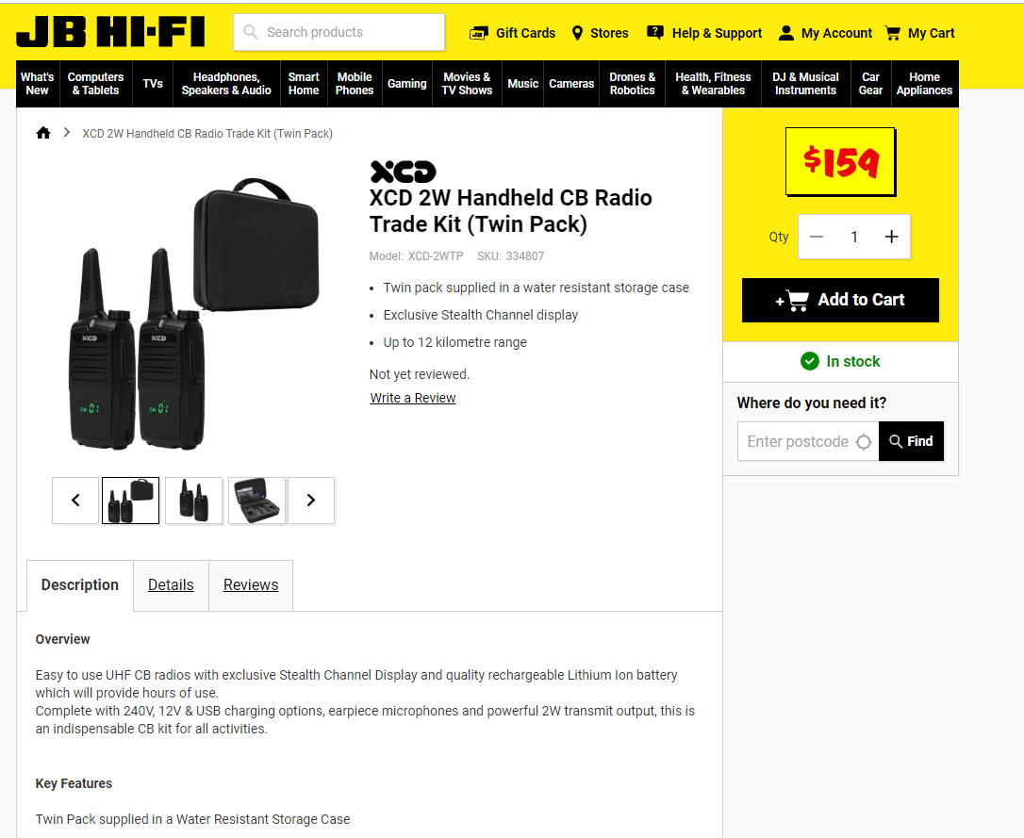

- Also need PA repaired by Oct muster (hopefully this is due to be included in the electricians scope along with speakers on the stable side of the grounds). – in action by Shane
Only 8 responses from survey, another email has been sent out to remind. Current issues: too much hanging around at rally not doing anything, aim to reduce this (discuss at instructors meeting)
Obstacle activities to use Mens Shed items – invite them to see it in use at October rally. (Shane to invite)
Gemma to propose a date for an obstacle day for use of Mens Shed items

Motion: The Events and Communications Coordinator Report be accepted into the minutes.
Moved: Gemma Burger Seconded: Shane Toll

CHIEF INSTRUCTORS REPORT
Forest ride this Sunday for muster – need to ensure parents available to ride
CT for October rally – instructors to release tests to allow practice. Decide on number of rings required - ?2. Arrange dressage judges – CL judge (experienced) and SL trainee judge. Potentially Nicky Greenaway, Cathy. Decide at instructors meeting
Activities/obstacles whilst not in SJ or dressage ring – ask Pam Andrews to coordinate
EOY rally – BBQ awards night and camp over Saturday night, then rally Sunday morning.

GROUNDS AND MAINTENANCE REPORT
Equipment
Damage to an external electrical connection to the canteen - next to the wash bay, was done some time ago by a stray cow. Some duck tap has been applied to the exposed wires to temporarily fix it, but a Permanent repair is required. Update: should be fixed soon Speakers as per President report
Obstacles for Rally Day
At our July meeting I was asked to approach the Bellbowrie Men’s shed to build some equipment for a rally day. The last of the three items have been completed. Keen to complete more works

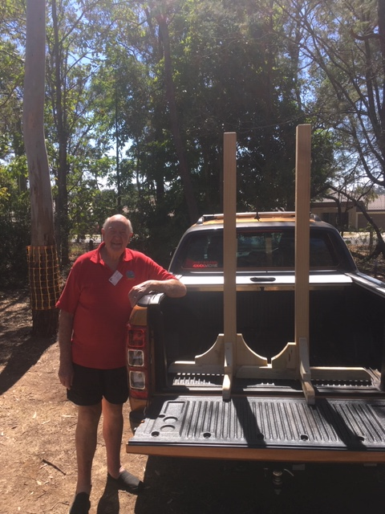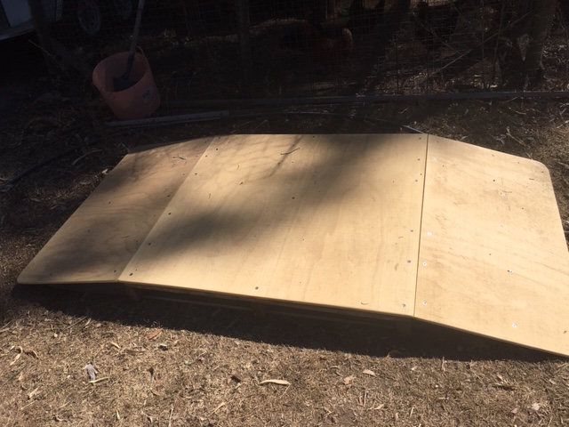
Outstanding works
Repaint of pole bases
Welding of new rails to jumping frames
Repair to electrical connection to canteen
Rewire of flood lights to canteen
Removal of fallen tree on boundary fence – top right corner
Clean up of corner - top of stables
Aeration of the fields once it rains (a local has a core aerator that we can use once it rains)

Stable Lighting
Should be finished in the coming weeks
PA System
Need to look into a better system as this was the only problem we had over the Hack Day.
If night rally is held communications to neighbours to advise will be organised

Motion: The Grounds and Maintenance Report be accepted into the minutes.
Moved: Shane Toll Seconded: Dan Foster

CANTEEN COORDINATOR REPORTS
Takings:

August Muster – 25 Aug 2019
A very quiet muster with low numbers.

Takings for the day $325.00
Total Costs $214.43
Profit $110.57
Carry over of stock to Hack Day: $50

Hack Day – 15 September 2019

Hack Day numbers were down; approximately half the numbers that we saw attend last year. McIntyre Centre was also not involved this year. The day was still a success and everyone who attended mentioned how well the day was organised. The coffee machine was placed outside of the canteen but near the canteen serving counter, this is proving to be an ideal location for coffee on busy days and is keeping the canteen free for food prep in the mornings.

Nominations – On Day $1,360.00

Raffle $162.00

Canteen
Takings for the day $1,631.70
Total costs $ 793.31
Profit $ 988.39

Judges meal costs: $55.00

Carry over of stock $150.00
As numbers were down half of the fresh food that could be frozen was put away, will utilise this for the October Rally.

Issues:

Drinks fridge is labouring and the light is turning off as the compressor uptakes. Reported to Ground Maintenance. Electrician when they come to install lights will have a look to see if it is an electrical issue or fridge. Fridge is still holding temp.

Changes:

Nil

Motion: The Canteen Coordinator Report be accepted into the minutes.
Moved: Di Toll Seconded: Belinda

VOLUNTEER REPORT
Email to be sent to volunteers with low hours
Reminder for those renewing of obligations
Volunteering for outside competitions
Previously for zone events Carmen has held BBQ and explained the T&C’s; potentially look at clinic before event for practice and then talk to parents
Motion: Volunteer Coordinator Report be accepted into the minutes.
Moved: Belinda Ryder Seconded: Di

UNIFORM COORDINATOR REPORT
nil
Motion: The Uniform Coordinator Report be accepted into the minutes.
Moved: Seconded:

ZONE REPORT
Moggill to put forward interest for zone event, plus official event to PCAQ
Metro Zone 1 should be releasing dates soon
PCA has published new syllabus of instruction ($106 for books), needed ASAP. Club organizes online – Keirra to organise
C Certificate riders need signing off - ? October/November dates for C Certificate clinic
Some riders of Moggill ready to start Cert K
PCA AGM – State President: Grant Lyneham
VP: NQ, Rockhampton, Zone 2 Jeff Thomson, Nambour

GENERAL BUSINESS
Robbie’s House

September Update

I have spoken with Robbie about designs, layout and how he would like his area, and the amount of work that is required. There is a considerable amount of clean-up that is required around Robbie’s van before containers can be brought in. Robbie does not want a hand with the cleaning up at this stage as he needs to sort as he cleans; Robbie has been given until start of November to have all his area cleaned up.
At this stage Robbie will removed the van as he wants to take it to his brother’s place. He is happy with the club providing a new home, but is concerned with the future - what if he wants to move, meets someone etc. I have told Robbie that the containers are sellable and the club would not lose money.

Containers
I am looking at containers and containers already converted; my aim is to have sourced 2 x 20ft containers by start of November for removal to site.

Time line
September/October - Robbie to clean up area and clean out shed for personal storage
Late October - Tree trimming, shrub clearing
November - Move containers to on site. Start fit out.
December - Robbie to move into new home

Layout
Placement of containers has been finalised with Robbie, see photos below.
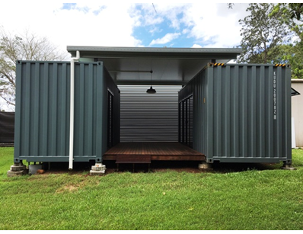
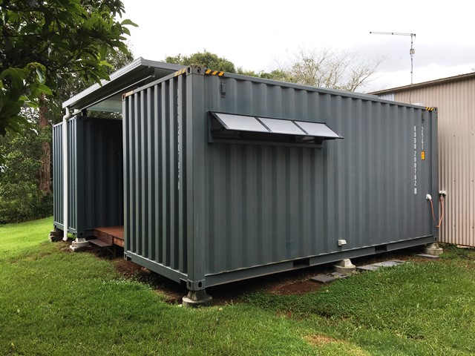
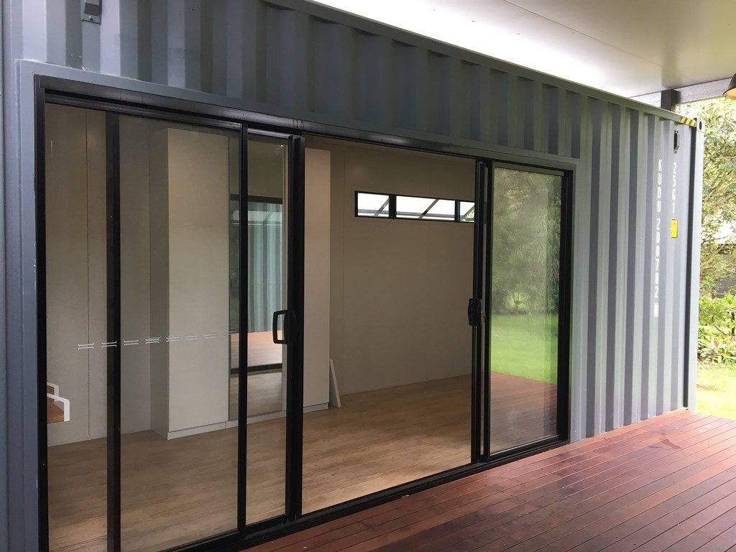
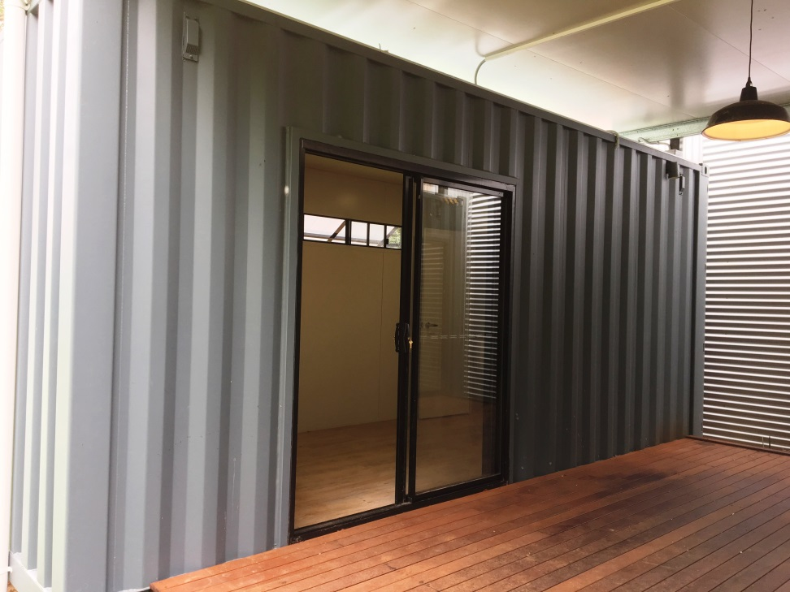
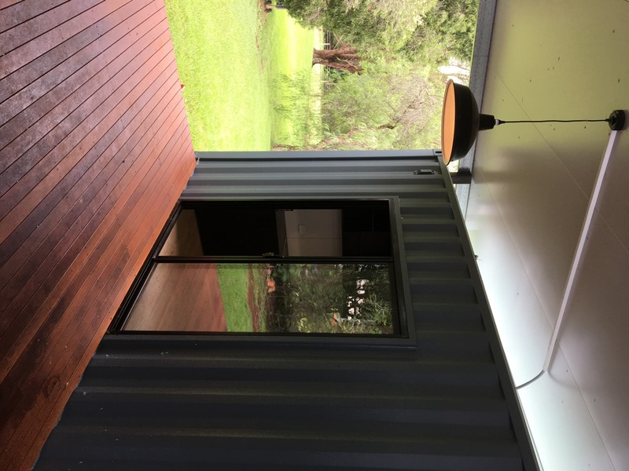

Next meeting: 4th November, 6.30pm for 7pm
Monday 2nd December for committee break up
Send calendar invite to all committee members
Meeting closed 2115

