MPC Committee Meeting Minutes
MOGGILL PONY CLUB
Location: Hitching Post Bar and Grill
Date: 18th July 2019
Time: 1900
- Meeting Opened
  - Welcome and apologies
Present: Gemma Burger, Di Toll, Belinda Ryder, Dale Innes, Shane Toll, Keirra Middleton, James Robinson, Tanya Holliman, Carmen Coombs
Apologies: Kelly Foster, Dan Foster
1.2 Disclosure of conflicts of interest - nil
1.3 Minutes of the previous meeting – motion that the minutes were a true and accurate record
Moved: James Robinson Seconded: Belinda Ryder
- REPORTS AND MATTERS FOR DECISION
  - PRESIDENTS REPORT
- Presidents Items

- Treasurer - send Dan message asking for financial report (James)
  - Transfer
    - Additional account with Heritage?
  - Once reviewed Report status and Target items to be addressed or implemented for the year.
    - Accounting Software
    - Cost and Income Codes

- Secretary
  - AGM Minutes need to be posted on website - completed

- Sponsorship
  - Sponsorship Information
    - Schedule - KF
  - Sponsorship Agreements - KF
    - Events
    - Grounds Signage
  - Sponsors
    - Scifleet – for $5,200 for 3 years
      - I need to make a frame $650
      - Printing as per quote
    - Brisbane Real Estate - $1,400 per year x 3 years (paid annually)
    - Hitching Post - $1,400 per year x 3 years (paid annually)
    - Solar Elec - $1,400 per year x 3 years (paid annually)
    - TMRP Builders - $750 per year x 3 years (paid annually)
    - Moggill Barn - $5,000 for 3 years 2 signs (paid up front, Mike has requested that he pays this invoice over the next 3 mths) - confirmed have not yet paid
    - Christian Rowan - MP $500 per year x 3 years (paid annually) - have requested invoice be issued 19/20 financial year
    - Julian Simmonds MP $500 per year x 3 years (paid annually)
    - Dan Foster please confirm that all the invoices have been issued??? - Any invoice issues please cc James , Keirra and Belinda
  - Signage Proofs and Quote from Brand
    - I have requested an $800 credit to have their own signage at the front gate for the next financial year.
    - Artwork Invoices (TGDC5477 $165 and TGDC5489 $198)
    - Tower Sign Frame $650 plus GST (Robinson Projects) Welding Labour
    - Welcome Sign Frame $2,390 plus GST (Robinson Projects) Welding Labour and Concrete and I donated the materials.
    - Dan Foster - please confirm that all the invoices have been paid - Gemma to authorise payment of outstanding invoices
  - Signage on Stables in Honor to Jane Prentice. I suggest we do the naming when we finish the second roof.

- Equipment
  - Equipment Wish List - all wishlist items to Gemma
  - Christian Rowan has confirmed the Stainless Steel BBQ - has also committed to more gazebos
  - Kate Richards has requested any purchase which she can put a council sticker on. I did ask for a new trailer but she didn’t like the cost. - Gemma to propose idea to Kate Richards with approximate cost of $5000.

- Constitution
  - I chased up Bernard Ponting regarding the constitution being issued - Belinda to type up copy of constitution

- Lighting
  - I have a rough budget for lighting of approx.
    - $200 per LED flood light
    - $350 for a cherry picker for the day hire (I will try and get this for free)

- Robbie’s House
  - The example caravans seem to still be a lot of work
- Grants
  - Community Grant
    - Kelly advised we have been successful in the $35k community grant
    - I will submit a quote from my company to finish the roof. Please note that we had heavily discounted the first stage of the stables and waited 10mths to be paid. The quote to finish is in line with the total costings that Brad Henderson had approved and is under all the other quoting that he had as a total package. I shall remove myself from the meeting for the decision of this works. - Kelly has all 3 original quotes. Project has been broken into 3 stages.
  - Council Grant
    - Kate Richards said that the $100k council grant has come around again and we should submit this one with a strong highlight on the fact that we are a non-profit club as per the constitution. Constitution does not state clearly we are a not for profit. New constitution being written up which clearly states we are not for profit. Constitution to go to Carmen.

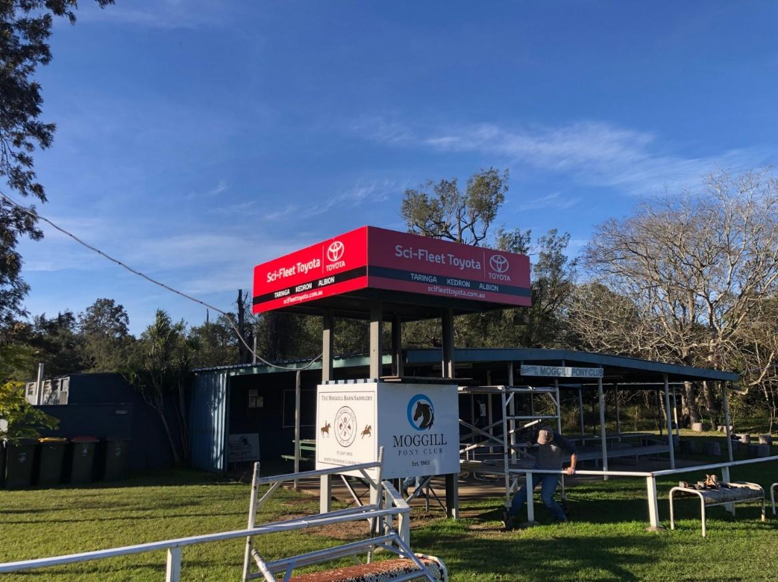

Proposal for discussion:
Sell Pony Club Grounds to Brisbane Council
- Council to acquire additional land (approx. $2m)
- Part of additional land to be Riparian area
- Balance to be additional horse grounds and New Club house
- Advantages to council is that they can use monies from
  - Open Space budget
  - Riparian and Vege management
- Monies raised from sale to go into building
  - New Club House
  - New under cover jumps arena
- Advantages for MPC
  - Negotiate now while in a healthy position
  - We can walk away if the deal doesn’t suit
  - We can demonstrate that we are a strong club
  - On our terms
  - We have balance land which would enable council to use funding that others
  - Use my contacts and experience
  - Major investment which will secure the club

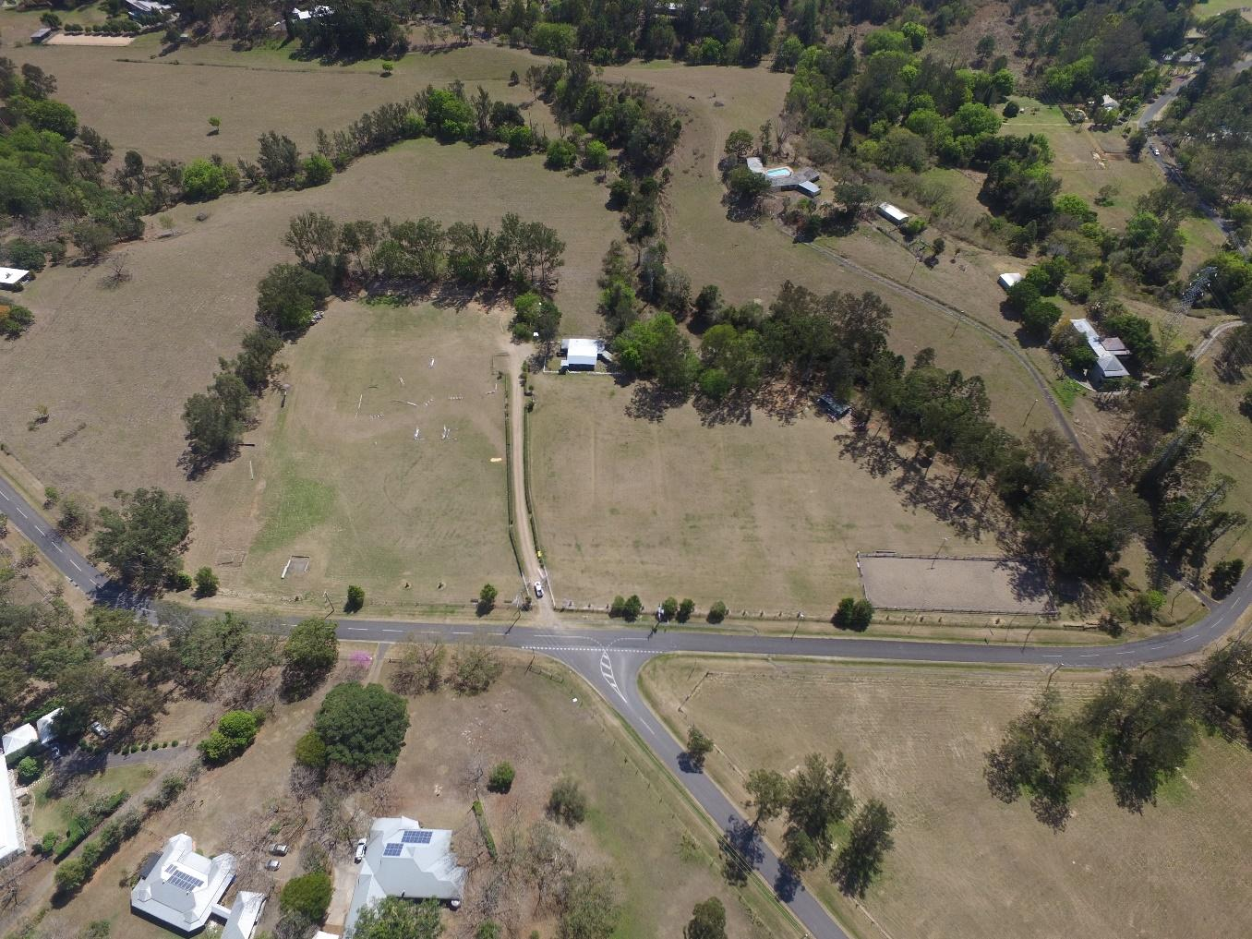

All in approval for James to discuss with mayor
Motion: The President’s Report be accepted into the minutes.
Moved: James Robinson Seconded: Belinda Ryder

  - MEMBERSHIP SECRETARY REPORT
Motion: The Membership Secretary Report be accepted into the minutes.
100 members!
Pro rata membership rates to be applied hereafter for rest of year
1 new member – Alicia Withers, with conditions in place.
Moved: Keirra Middleton Seconded: Gemma Burger
  - TREASURERS REPORT
$23485 current bank balance (plus grant of $35K), plus term deposit

  - EVENTS AND COMMUNICATIONS COORDINATOR REPORT
- Need some clear direction around which new sponsors to promote and what commitment has been given as well as logos - done
- review of survey questions already forwarded Q7, impact volunteering Q; open ended questions good
- need someone to take on approaching sponsors for the hack day, I will put a package together by next week – James friend at Sci fleet will sponsor; JoAnne Sleep organizing raffle
- ideas to celebrate reaching 100 members
  - Evening casual function at the Hitching post
  - sausage sizzle at a rally?
  - Horsey trivia night - members only, different questions for different age groups
  - Campfire, drinks and spotlight games at the club – winner! 10th August. A Night Under the Stars, 1730. Long table
- any suggestions??
- Suggestion for an “Obstacle Day” non competitive have a go with a flat fee entry with additional competitive working equitation. Could ask Kenmore Men’s shed if they would help us build some obstacles such as bridges, see saw bridge, gates etc.
- need to look at dates - possible Sunday 1st September or 6th October? 6th October
- need to pick a date for Goodwill Gymkhana possible Sunday 1st September or 6th October? Invite KD, Brookie and Yarrawa to Obstacle Day instead – pony club membership required
- re last rally of the year and Kelly’s suggestion this will need discussion by instructors committee before bringing to the committee for discussion instructors will bring recommendation next meeting
- Wishlist
  - Repair Flood lights
  - Fix PA system and extend to stable block
  - Jump Trailer
  - Repair other trailer for dressage arenas
  - Red frogs & new soccer ball
  - Obstacles
  - Repair and build new XC jumps
  - Flagging set/full sporting equipment set to run a full gymkhana
  - Storage cupboards, filing cabinet (raised above flood level) and drawers in the club room
  - Overhead projector or ability or connect TV to smart phone & laptop
  - Paint floor of toilet block
  - Add shower facility in ladies or change male to unisex with lockable doors?
  - Repair or replace fencing on round yard
  - Extend dressage arena to 60 x 20m, improve surface and replacing fencing
  - SJ rails and wings – enough to have a full quality SJ course
- could we organise a pole painting working bee

Motion: The Events and Communications Coordinator Report be accepted into the minutes.
Moved: Gemma Burger Seconded: Dale Innes
  - CHIEF INSTRUCTORS REPORT

  - GROUNDS AND MAINTENANCE REPORT
Equipment
- Whipper snipper has been purchased
- Grounds have not needed any maintenance
- Slasher oversized for tractor . Worth $800-1200, a new one would cost $1800.
- Motion put forward to sell current slasher and purchase a new one. All in attendance in agreeance. ACTION item: Shane

Motion: The Grounds and Maintenance Report be accepted into the minutes.
Moved: Shane Toll Seconded: Di Toll

  - CANTEEN AND VOLUNTTER COORDINATORS REPORTS
Pattern seems to be April, May, June, July musters seem to be quieter

  - VOLUNTEER REPORT
Motion: The Canteen and Volunteer Coordinator Report be accepted into the minutes.
Moved: Di Toll Seconded: Belinda Ryder
  - UNIFORM COORDINATOR REPORT

  - ZONE REPORT
Reminder that riders under the age of 18 need to have a non riding person over the age of 18 with them whilst on pony club grounds.
Adult riders should ideally have another adult present
18th August Aitkens SJ at Runcorn. 1 day competition only on Sunday
Adult riders now allowed to ride at state championships
Moggill PC has run 2 zone comps 2 years in a row; need dates for next year’s event (Zone events) by August meeting. If wanting to run official events, also need to consider requirements for same and put in for dates
- GENERAL BUSINESS
  - Robbie’s House
Proposal:
- Replace current van with another Van – like for like residence with not raise issues with council.
- Clear current area including all overgrown growth up to and maybe including shed and re-level for
- new van.
- Create a space and garden for Robbie to feel comfortable includes building a deck with cover and an enclosed garden space.
- A structural cover over the van should also be considered, this will prolong the life of the van and reduce degradation.
Cost: $10,000
Van requirements:
- Over 20ft - this will provide a bedroom, separate dinning lounge area and full kitchen
- Island bed – desirable
- Shower and toilet
- Full kitchen facilities
- Air conditioner
- Washer/dryer
- Electricity connect to van – no power cords
- Plumbing connected to van for running water and waste/greywater

Current Issues
While we are all familiar with Robbie and know that he is a great guy who is only too willing to help out, others do not know Robbie, are not aware that he is actually our caretaker and see him unfortunately as an undesirable. This perception is brought about through the state of the van and the area around the van.
The current arrangement of shared bathroom facilities for our caretaker and ground users including those who choose to camp, is not acceptable. Robbie will not use the bathrooms (includes toilet for our non MPC musters) when the grounds are rented out ie no shower.
The shower in the male toilet needs to be addressed as a separate issue. By providing new living quarters and a cleaned up outdoor and garden space we achieve the below:
- Our duty of care to our caretaker
- Suitable residence
- Own bathroom facilities
- Outdoor space will aid in Robbie having a space to call his own – mental health
- Acknowledgement to our club members that Robbie is safe.
- Robbie’s own health improving
- Robbie can actually have a home he can bring friends home to
- Do laundry - I am not even sure how he it does this at the moment.

A contract will need to be drawn up between the club and Robbie that acknowledges Robbie as our grounds caretaker and that he will be responsible for his own area, that it is to be maintained in a neat and tidy state at all times. The club acknowledges that this is Robbie’s space in exchange for ground maintenance as requires.
Funding
There are no grants available that can be used to assist in the cost of providing accommodation; funds are going to have to come from sponsorship money. Suggestions:
- James has been successful in sourcing recent sponsorship funds, suggest we use $10k to
- source van and do any necessary work to the van ie paint, re fabricate seating etc
- Roof over van – Kelly has been successful in obtaining a $35k grant, as this is roofing we
- can slid it under the grant if there are funds left over.
- Decking Roof – again roofing so can slide under stable roof grant.
- Decking – built by volunteers, timber sourced and hopefully I can get it donated. Not
- looking at a large deck, 5 x 3 mt – enough space to have an outdoor setting &amp; BBQ.
- Electricity to van – can be covered under grant as we will be running power over to the stables
- Plumbing for van – can be covered under grant as we will require plumbing for the water runoff from the stable roofs.
- Any incidentals required to fit out the van, cutlery, crockery, linen, cooking items to be sourced through club donations.

Outdoor area
The idea is to create an outdoor space where Robbie can enjoy, can entertain if he chose’s, enjoy a beer and hang his laundry all in a secluded space. The outdoors is also important for health wellbeing. My idea is to clear the space between the existing van and shed (yes there is a shed in there) remove the existing barrier which comprises of a cloth and round yard fencing and plant a hedge – over time this will provide a natural screen. In the short term erect cheap bamboo screening behind the hedge. No other plants and it is up to Robbie if he chooses to lawn the area between deck and hedge.
Costs
- Source Van for under $10k. If it has everything and over budget will be brought back to committee for discussion. Currently there have been a few vans around $8,500 that has bones but need a face lift via internal and external painting and general fit out through re-covering, linen and lighting. All of these costs would come in under $1,500.
- Decking roof – 5m x 3m insulated roofing $45 per/linear mt x 15 linear mt = $675, would need guttering can capture in plumbing costs.
- Van Roof - $1,500 - $2,000. Would be good to use colorbond (grey) to make it disappear
- into the environment rather than stand out. Powder coated sheet $21.50
- Decking – approx. size 5m x 3m. Built by volunteers, hopefully decking, piers and supports donated
- Small hedge plants – hopefully I can get at reduced priced, but costs $150
- Bamboo Screening – 1.8 x 3m lengths $20.97 x 10 = $209.70

MPC Grant Sponsorship
- Van $8,500
- Fit out $1,000
- Van Roof $2,000
- Electrical $ 500
- Plumbing $ 500
- Deck Roof $1,500
- Decking $1,500
- Plants $100
- Screening $209.70

- Queries as to use of 35K grant to fund part of the project.
- Suggestion of a separate sub-committee to manage Robbie’s housing project

OUTSTANDING ACTION ITEMS PREVIOUS MEETINGS
Ref | Action Items | Owner(s) | Deadline | Status
04/19 – 01 | AGM minutes | Keirra Middleton |  | Complete
04/19 – 02 | Grounds sign (signwriter) | James Robinson |  | Complete

Next meeting 15th August, 6.30pm for 7pm
Meeting closed 2108

