# MPC Committee Meeting Minutes

**MOGGILL PONY CLUB**

**Location**: 88 Hawkesbury Road, Moggill  
**Date**: 22nd August 2019  
**Time**: 1900

  
  


1. Meeting Opened
   1. Welcome and apologies

Present: Gemma Burger, Di Toll, Belinda Ryder, Dale Innes, Keirra Middleton, James Robinson

Remote Dial in: Kelly Foster, Carmen Coombes

Apologies: Dan Foster, Tanya Holliman

1.2 Disclosure of conflicts of interest - nil

1.3 Minutes of the previous meeting – motion that the minutes were a true and accurate record

Moved: James Robinson Seconded: Belinda Ryder

1. REPORTS AND MATTERS FOR DECISION
   1. PRESIDENTS REPORT

Presidents Items

• MOGGILL PONY CLUB IS A NON-PROFIT ORGANISATION

o I want everyone to be very clear and every member must support this 100% in any

representation.

o I have spoken to Bernard Ponting last week and he will be sending an advice letter

which can be used in any submissions.

o I would like the NON-PROFIT term/words used on our website and literature.

• Treasurer

o Transfer

▪ Additional account with Heritage?

• Secretary

o Typing of the Constitution changes. Gemma has the files

• Sponsorship

o Sponsorship Information

▪ Schedule - KF

o Sponsorship Agreements - KF

▪ Events

▪ Grounds Signage

o Sponsors

▪ Moggill Barn $5,000 for 3 years 2 signs (paid up front, Mike has requested that

he pays this invoice over the next 3 mths). Dan has confirmed the first

instalment has been paid

▪ Christian Rowan MP $500 per year x 3 years (paid annually)??

▪ Julian Simmonds MP $500 per year x 3 years (paid annually)??

▪ Brisbane Realestate invoice $1,400 per year x 3 years (paid annually)??

o Dan Foster please confirm that all the invoices have been issued??? – invoices emailed to be clearly marked

• Signage on Stables in Honour to Jane Prentice. I suggest we do the naming when we finish the

second roof. I would like to do this on the Hack Day 15 th September – also to acknowledge the source of the funds ie: grants

• Equipment

o Equipment Wish List

▪ Christian Rowan has confirmed the Stainless Steel BBQ

• I have spoken to Dan in Christian’s office and I have been promised the

BBQ for Hack Day.

Kate Richards has requested any purchase which she can put a council sticker

on. I did ask for a new trailer but she didn’t like the cost.

• Gemma and myself attended a meeting with Kate and from this we

have commitment of $3,400 towards equipment.

Invite to be sent to politicians for hack day

• Constitution

▪ I chased up Bernard Ponting regarding the constitution being issued

• I have spoken to Bernard and told him that the club will get the

constitution typed up and he would provide us an advice letter that we

have always been a non-profit club. Sent him a reminder email

12/08/19.

• Lighting

▪ Getting a quote for lighting to the stables and the flood lights at the club house

• Robbies House

o I don’t think the caravan idea will work as the price point we are looking at still requires

a lot of work.

• Grants

o Kate Richards said that the $100k council grant has come around again and we should

submit this one with a strong highlight on the fact that we are a non-profit club as per

the constitution. – 6th September deadline for Stronger Communities grant

▪ Kelly you need to apply for this and the typed constitution and advice letter.

• Stable Roof

o Stable Roof Finished

o Electrical quote sent to Shane to present

o If I can organise my guys to do the excavation I can do the extra maintenance things

for free, like the arena and round yard sand and manure pile etc (my machines are busy

in Beaudesert at the moment).

Motion: The President’s Report be accepted into the minutes.

Moved: James Robinson Seconded: Gemma Burger

* 1. MEMBERSHIP SECRETARY REPORT

New members: Belinda Cox, Jackie Doyle and Taylor Hopkins

AGM of Pony Club Assoc of Qld: 5th September

Applications for hosting State events now open. Expectation for us to host events due to size of club. Difficulties with space and facilities.

Zone 1 events more doable. Expression of interest to be presented for JF McGill, SJ, Dressage and CT, Teams Challenge

**Motion: The Membership Secretary Report be accepted into the minutes.**

Moved: Keirra Middleton Seconded: Belinda Ryder

* 1. TREASURERS REPORT

## Treasurer – Balance sheet

## 21 August 2019

Current Balances as of 21 August:

|  |  |
| --- | --- |
| Building Fund | $35,040.00* |
| Term Deposit – Levies | $5,744.42 |
| Transaction Account | $19,741.25 |
| **Net Position** | **$60,525.67** |

*Includes $35,000.00 building grant.

**Future liabilities:**

|  |  |
| --- | --- |
| Urban Utilities** | $1,330.24 |
| **Total** | **$1,330.24** |

**On monthly $100 payment plan.

Debtors

|  |  |
| --- | --- |
| HQ Solutions*** | $250.00 |
| Moggill Barn**** | $3,332.00 |
| Westvets | $500.00 |
| **Total** | **$4,082.00** |

*** HQ Solutions outstanding since 23 April. For sponsorship.

**** Moggill Barn paying in 3 instalments. 1st payment of $1,668.00 received 22 July. Original total $5,000.00

**Net position for transaction account if all liabilities & debtors paid in full = $22,493.01**

**Net position of all accounts if current liabilities paid in full = $59,195.43**

**Net position for all accounts if all liabilities & debtors paid in full = $63,277.43**

**Request for P&L statement from treasurer.**

**Projected and actuals for sponsorship money required**

**Motion: The Treasurer Report be accepted into the minutes.**

Moved: Dan Foster Seconded: Belinda Ryder

* 1. GRANTS CO-ORDINATOR REPORT

|  |  |  |  |  |  |  |  |  |  |  |  |  |  |  |  |  |
| --- | --- | --- | --- | --- | --- | --- | --- | --- | --- | --- | --- | --- | --- | --- | --- | --- |
| **Potential Grants** | **Amount** | **Due** | **Criteria** | **Column1** | **Column2** | **Column3** | **Column4** | **Column5** | **Column6** | **Column7** | **Column8** | **Column9** | **Column10** | **Column11** | **Column12** | **Column13** |
| Gambling and community benefit fund | 35000 | 31-08-19 | Leisure facilities to encourage participation in sport | | | | |  |  |  |  |  |  |  |  |  |
| Brisbane Healthy & Physical Activity Grant | 20000 | 02-09-19 | Provides funding to local non-profit community groups for projects to increase participation in community sport, recreation and physica | | | | | | | | | | |  |  |  |
| BCC Stonger Communities | 100000 | 09-09-19 | Improve the quality of a facility | | |  |  |  |  |  |  |  |  |  |  |  |
| Sunsuper | 50000 | 13-09-19 | Funds dreams to help an Australian-based charity, community group or not-for-profit organisation make a real difference in the community. | | | | | | | | | | | |  |  |
| Suez | 15000 | 20-09-19 | Provides community groups, schools and organisations from across Australia with funding to help improve their local communities | | | | | | | | | | |  |  |  |
| Flying start Jetstar | 15000 +15000 | 30-09-19 | Invites community groups and organisations across Australia to apply for a grant to fund a project that will enrich the lives of people in their community - includes sport | | | | | | | | | | | | | |
| Stronger Communities Federal | 20000 | 10-10-19 |  |  |  |  |  |  |  |  |  |  |  |  |  |  |

**Motion: The Grants Co-Ordinator Report be accepted into the minutes.**

Moved: Kelly Foster Seconded: Belinda Ryder

* 1. EVENTS AND COMMUNICATIONS COORDINATOR REPORT

### Hack Day – 15th September

* Priority for organisation and promotion currently is the hack day.
* So far 3 sponsors confirmed as West Vets for $500, Eurofloat Supreme prizes, Horseland Champion prizes, Moonbah browband for prize
* 4 judges all confirmed
* Program finalised apart from any additional sponsors logos
* Commitment from Kate Richards for $3,400 for equipment for the event. Have requested as below – no further response yet

|  |  |
| --- | --- |
| **Wishlist** |  |
|  |  |
| **Item** | **Approx costing** |
| **Gymkhana** |  |
| 500m Bunting | $ 837.00 |
| 4 x storage bins for bunting | $ 260.00 |
| 30 x Gymkhana pegs | $ 210.00 |
| 2 x pair of jump blocks | $ 499.90 |
| 2 x Flagging sets | $ 140.00 |
| 1 x dual stop timer | $ 780.00 |
| 6 x Barrels | $ 240.00 |
| 50 x Tread in posts for bunting | $ 247.50 |
| Horse Soccer ball | $ 185.00 |
| **Total** | **$ 3,399.40** |

* Will need to purchase prior to hack day and send receipts to Kate Richards office for reimbursement
* Need PA to be fixed by hack day

Committee approval for purchase of sashes/rosettes: all in favour

* Other 2019 events:
  + September rally both adults and regular rallies to be forest rides – TBC venue waiting on council to confirm best access and parking venues.
  + **PROPOSAL –** 21st September Private Advance Screening movie night at Elizabeth Picture Theatre of “Ride Like a Girl”
    - Tickets cost to MPC $11/head if 60 people theatre or $18/head if 40 people.
    - Plus food/drinks – served at seat, can include alcohol, confirming but think people can just order and pay for what they would like)
  + 6th October – obstacle day. Details to be released soon (just getting hack day under way first.) Shane coordinating with Mens shed Bellbowrie to make obstacles, prototypes hopefully not too far away. Will include competitive component as well as generally training. Will need to be PCQ only or run as a clinic for potential to be an open day.
* We need to consider dates for next years calendar for events to request dates with PCQ. Suggested dates:

|  |  |  |
| --- | --- | --- |
| **2020 MPC Dates** | | |
|  |  |  |
| 25 - 26th Jan | Back to Pony Club camp | Change to 8th 9th Feb – Saturday to Sunday midday |
| 9th Feb | Adult riders |  |
| 23rd Feb | Rally |  |
| 8th March | Adult riders |  |
| 22nd March | Rally |  |
| 5th April | Formal Gymkhana? |  |
| 12th April | Adult riders | School holidays - reschedule? |
| 26th April | Rally |  |
| 10th May | Adult riders | Reschedule to 17th May to allow for Comp? |
| 10th May | Official CT or SJ? |  |
| 24th May | Rally |  |
| 14th June | Adult riders |  |
| 28th June | Rally |  |
| 12th July | Adult riders | School holidays - reschedule? |
| 26th July | Rally |  |
| 9th August | Adult riders |  |
| 23rd August | Rally | Maybe approach Brookfield for Goodwill Gymkhana as this clashes with Long Lunch so they won't be able to have their rally that week I think? |
| 6th September | Adult riders | Forest Ride |
| 13th September | Hack Day |  |
| 27th September | Rally | Forest Ride |
| 11th October | Adult riders | School holidays - reschedule? |
| 25th October | Rally |  |
| 8th November | Adult riders | Winery/pub ride |
| 22nd November | Rally | Awards & fancy dress |

* Also apply to Zone 1 to host one or more of the Zone events

**Motion: The Events and Communications Coordinator Report be accepted into the minutes.**

**Moved: Gemma Burger Seconded: Keirra Middleton**

* 1. CHIEF INSTRUCTORS REPORT
  2. GROUNDS AND MAINTENANCE REPORT

Equipment

Damage to an external electrical connection to the canteen - next to the wash bay, was done some time ago by a stray cow. Some duck tap has been applied to the exposed wires to temporarily fix it, but a Permanente repair is required. Update this will be fixed in the next week.

Obstacles for Rally Day

At the last meeting I was asked to approach the Bellbowrie Men’s shed to build some equipment for a rally day. After a couple of meeting we have sourced some wood and Ewen has made the first of three obstacles for the club. The men’s shed are happy to build items there is a small cost to cover the power and materials (eg screw, extra wood) I am awaiting the invoice for the below but should not be more than $40-50.

I would like to put forward that we put a formal invite out the members of the shed on the day that we are going to use the equipment.

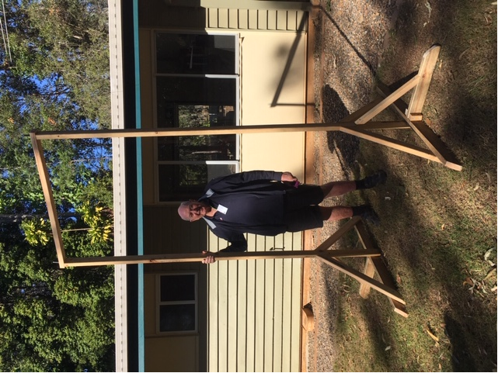

Outstanding works

Repaint of pole bases

Welding of new rails to jumping frames

Spraying of long and round yards and all fence lines

Repair to electrical connection to canteen

Rewire of flood lights to canteen

Removal of fallen tree on boundary fence – top right corner

Clean up of corner - top of stables

Stable Lighting Quote

Find attached the first quote for the lighting for the new stable area, I am in the process of getting another quote but as it is a busy time of year the quote will not be ready until the weekend I will forward once I have received it for consideration.

Round yard post is broken, possibly from termites eating it out. Needs fixing/replacing

Motion: The Grounds and Maintenance Report be accepted into the minutes.

Moved: Shane Toll Seconded: Di Toll

* 1. CANTEEN COORDINATORS REPORT

Takings:

July Muster – 28 July 2019

A very quiet muster with low numbers. I passed the canteen over to Jo-Anna Sleep to run for the muster as I was away for that weekend. July muster was an in-house Formal Gymkhana, there was a $10 entry fee per rider to cover ribbon costs

Entry Fee $220.00

Uniform Sales $180.00

Takings for the day $285.70

Total Costs $153.37

Profit $132.33

Social Evening – 10 August

A great night! Support was good and everyone who attended enjoyed the social aspect of the evening. A bar was provided along with nibbles & soup. A attendance fee of $10 per adult & $5 per child was charges to cover food costs and included a complimentary drink. To reduce the need for committee members having to man the bar and attend to food service, 2 older siblings of club members were employed for the evening at a cost of $100 each.

Attendance fee pd $325.00

Takings for night $293.50

Alcohol Costs $309.60

Food Costs $215.46

Staff x 2 @ $100ea $200.00

Profit -$106.56

Carry over stock of Alcohol $160.00

Issues:

Drinks fridge is labouring and the light is turning off as the compressor uptakes. Reported to Ground Maintenance. Electrician when they come to install lights will have a look to see if it is an electrical issue or fridge. Fridge is still holding temp.

Next 2 musters are very lite on for volunteers in the canteen – 1 volunteer for each muster.

Changes:

Nil

**Motion: The Canteen Coordinator Report be accepted into the minutes.**

**Moved: Di Toll Seconded: Keirra Middleton**

* 1. VOLUNTEER REPORT

Volunteer Report

|  |  |  |
| --- | --- | --- |
| Milestone | Volunteer | Amount |
| Annual Volunteer Hours - Per Family | Roz Bolton | 39.5 |
| Annual Volunteer Hours - Per Family | JoAnne Sleep | 31.5 |
| Annual Volunteer Hours - Per Family | Rachel Green | 26 |
| Annual Volunteer Hours - Per Family | Anna Hamilton | 24 |
| Annual Volunteer Hours - Per Family | Anthony Owen | 23 |
| Annual Volunteer Hours - Per Family | Margaux Harris | 23 |
| Annual Volunteer Hours - Per Family | Cheryl Nell | 22 |
| Annual Volunteer Hours - Per Family | Felicity Rous | 20 |
| Annual Volunteer Hours - Per Family | Jeannie Evans | 20 |
| Annual Volunteer Hours - Per Family | Leisha Bennett | 18 |
| Annual Volunteer Hours - Per Family | Ed Bull | 17.5 |
| Annual Volunteer Hours - Per Family | Ari Kaufman | 17 |
| Annual Volunteer Hours - Per Family | Wendy Tozer | 16.5 |
| Annual Volunteer Hours - Per Family | Uma Vanderwaal | 16 |
| Working on it | Julie Cooney | 15 |
| Working on it | Mia Reeve-Johnson | 14 |
| Working on it | Shayna Smith | 13 |
| Working on it | Ben Woodhouse | 10 |
| Working on it | Sarah Pearce | 10 |
| Working on it | Danielle Little | 8.5 |
| Working on it | Helen Huie | 8 |
| Working on it | Fiona Kearney | 7 |
| Working on it | JOANNA DZIADUCH | 7 |
| Working on it | Cindy-Jane Richards | 4 |
| Working on it | Janet Ingram | 3 |
| Working on it | Liza Shaw | 1.5 |
| Working on it | Debbie Woodman | 0 |
| Working on it | Justine Temby | 0 |
| Working on it | Robin Sansbury | 0 |
| Working on it | Simone Everett | 0 |
| Working on it | Tania Alves | 0 |

* For future musters I would like to list the scheduled volunteers on our Facebook site – this will encourage ownership of the duty and ensure each person is aware of their duty just in case they don’t check their email
* I will be emailing all the members in the red zone to notify them they will be liable for fees if volunteer hours are not completed as per the agreement by end of year
* Initial email has been sent to all members regarding volunteering for T-Shirt Hack Day
* Need to address current issue of volunteering for outside events – all members need to accept part of nominating for pony club events usually involves volunteering at the event

**Motion: The Volunteer Coordinator Report be accepted into the minutes.**

**Moved: Belinda Ryder Seconded: Dale Innes**

* 1. UNIFORM COORDINATOR REPORT

Shirts, vests and badges are low in stock

Possibly stock white shirts

Zone 1 uniforms owned by PC to be signed out and $50 deposit paid

Motion: The Uniform Coordinator Report be accepted into the minutes.

Moved: Dale Innes Seconded: Belinda Ryder

* 1. ZONE REPORT

MPC needs to decide if sending any delegates to AGM. 2 delegates names if wanting to vote for any member nominations. – Moggill to nominate Carmen for zone President

Congratulations to all Moggill riders at Aitkens SJ, very impressed with riders who participated in picking up rails etc

MPC needs to think about zone events they want to run

No zone meeting this month, next one is 23rd September. All EOI’s need to be in for this meeting. (JF McGill, SJ, CT&dressage)

C Certificate to be run later in year.

Zone teams SJ challenge paperwork to be out n next few weeks

Carmen

1. GENERAL BUSINESS

Initial outlay for Robbie’s house: $7000 – everyone in agreeance

* Next meeting : 12th September 2019
* Meeting closed: 2120



QUOTE

26 Rupicola Place

Chapel Hill QLD 4069

E: matt@rcse.com.au

P: 0412 001 478

www.rcse.com.au

License No: 74223

Moggill Pony Club

40 Obrien Road

Pullenvale

Queensland 4069

Australia

**Date**

19 August 2019

**Expiry Date**

18 September

2019

**Quote Number**

QT00117

**ABN**

94 664 403 304

Supply & Install 25mm XLPE Mains from Clubhouse to Stables

Supply & Install 2 x 50A MCB Main switch

Supply & Install weatherproof switchboard on Stable

- 20A Safety switch

- 10A Safety switch

Supply & Install 12 x LED Batten lights

Supply & Install 4 x Pneumatic switches

Excavation Allowance $1,200+GST

Supply & Install GPO for Pump

Supply & Install 4 x GPO's (2 for each Stable)

Supply & Install 2 x 30w Flood lights

Supply & Install 7 x 200w Flood lights

**Total AUD 8,738.40**

Total GST 794.40

Subtotal 7,944.00

Thank you for the privilege to quote for the works required. We welcome discussion on this quotation. Please

contact our office on the above details should you have any questions (note this document number).

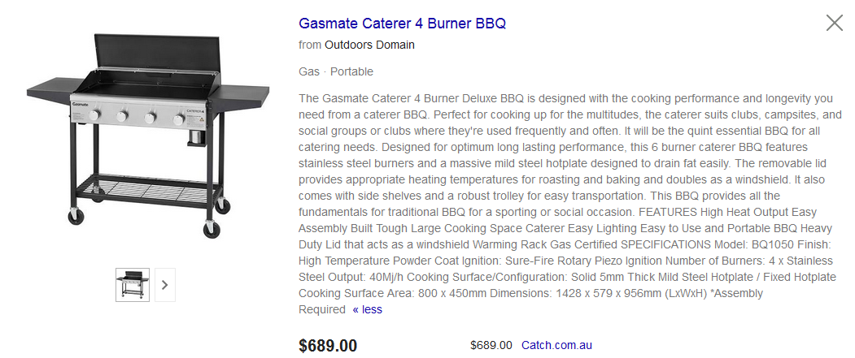



Preferred BBQ styles and options – BBQ’s listed in preferred order. BBQ needs:

* To be hard wearing
* Wind shield from burners
* Lid
* Side shelves
* Fat catcher
* Cover
* Min 4 burner